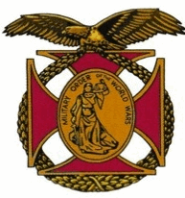

Meeting of the General J. P. Holland Chapter of the MOWW
September 3rd, 2016

The Chapter gathered at the Bernardo Heights Country Club at 1100

The meeting was called to order at 1135 by Chapter Commander, Nick Herbka. Carl Swepston (substitute Chaplain) offered the invocation, Andre LeCault led the Pledge of allegiance, and Arnold Regarde read the Preamble.

Chapter Commander introduced guests:
Department of California Commander, Clark Kholos
Guest Speaker, CDR Jessica O’Brian, USN

New Business:
- Installation of New Member David Piontek by Clark Kholos
- Vote on purchase of 200 Chapter Challenge Coins. Approved without objection

Lunch was served at 1215

During lunch the guest speaker, CDR Jessica O’ Brian, USN, Commanding Officer BMU-1, gave an informative talk about the role of the Navy Beachmaster Units in amphibious Warfare.

Following her presentation, Nick Herbka and Tom Lettington presented a Certificate of Appreciation. A Chapter Challenge coin was presented to our Guest Speaker

Cark Swepston gave the benediction, and the meeting was adjourned at 1350.

